IRC working group Global Energy Balance (GEB)
Annual Report 2010

Martin Wild and Norman Loeb (WG Co-chairs),
with input from Chuck Long, Ells Dutton, Crystal Schaaf, Nikos Hatzianastassiou, Xiquan Dong and Greg Kopp (WG members).

- Current Status/Objectives/Activities

A new IRC working group “Global Energy Balance” has been proposed and accepted at the IRC business meeting during IAMAS Montreal on July 24, 2009. The main goals of this working group are the assessment of the magnitude and uncertainties of the components of the global energy balance, their decadal changes and underlying causes as well as their significance for other climate system components and climate change.
In the first year, several WG members have been appointed based on their specific expertise required to achieve the goals of this working group. These members include 1) Chuck Long (Pacific Northwest National Laboratories), for his expertise in surface radiation measurements and radiative flux analyses, particularly his clear sky detection algorithm (Long and Ackermann 2000 JGR). This allows the estimation of radiative flux climatologies not only under all-sky, but also under clear-sky conditions; 2) Chrystal Schaaf (Boston Unversity) for her expertise in satellite derived surface albedo, required to infer absorbed surface solar radiation from measurements of incoming solar radiation; 3) Ells Dutton (NOAA/ESRL), for his expertise in radiation measurement, statistical analyses, quality control and BSRN management; 4) Xiquang Dong (University of North Dakota), for his expertise in analyzing both surface and satellite datasets; 5) Nikos Hatzianastassiou (University of Ioannina, Greece) for his expertise in satellite-derived surface radiation products; and 6) the newest member Greg Kopp (University of Colorado) for his expertise in total solar irradiance measurements. These members complement the expertise of the Co-chairs on top-of-atmosphere (TOA) radiation fluxes (Norman Loeb NASA Langley) and surface radiation fluxes (Martin Wild, ETH Zurich).
In the reporting year, preliminary studies have been initiated at ETH Zurich combining surface and satellite observations (see Section II). Also, in collaboration with the group of Xiquan Dong, complementary analyses of combined surface and satellite data have been initiated, as well as investigations on their representation in climate models (see Section II). To substantiate this research and in line with the goals of this working group, a joint research proposal has been submitted to NASA on March 25, 2010, entitled “Investigation of Radiation Budgets and their Interannual Variability Through an Integrative Analysis of CERES-BSRN Observations and ECHAM5-HAM Simulations”.
On an initiative of Bob Cahalan, a summary and recommendation paper on the current status of the global energy balance has been prepared by this WG. The recommendations stated in that paper are also included in the present annual report.
On June 1, 2010 WG Co-chair Martin Wild was invited to act as a lead author of IPCC 5th assessment report (AR5) Chapter 2 “Observations: Atmosphere and Surface”. This should facilitate the immediate transfer of the findings of the GEB-WG into the IPCC process.

- Research Results

ETH Zurich founded two databases for the worldwide measured surface radiation fluxes, the Global Energy Balance Archive (GEBA) and the Baseline Surface Radiation Network (BSRN) (now hosted by the Alfred Wegener Institute in Bermerhaven). GEBA contains 450’000 monthly mean values of surface radiative fluxes at more than 2000 sites, many of them with multidecadal records. The database of BSRN includes surface radiation measurements at high temporal resolution (minute values) with the highest possible accuracy at selected sites in different climate regions (currently about 40 anchor sites starting in the 1990s). These data can be used as anchor sites to constrain and evaluate satellite-derived products of surface radiation fields as well as radiative fluxes simulated with global and regional climate models.
Measurements from these two databases can also be used in combination with measurements of top-of atmosphere fluxes from satellites to obtain not just estimates of surface and TOA radiation budgets, but also atmospheric column absorption. This quantity is still poorly constrained and global climate models show accordingly largely differing estimates (e.g. Wild 2008). In a preliminary study we combined BSRN and GEBA surface climatologies with TOA flux climatologies from the CERES-EBAF dataset (Loeb et al. 2009), to obtain shortwave atmospheric column absorption estimates at the anchor sites. These anchor sites can then be used to evaluate and constrain satellitederived products which provide the large scale patterns (e.g. Hatzianastassiou et al. 2005). An example of a 5-year mean seasonal climatology of surface, atmospheric and TOA radiation balance at the BSRN site Lauder in New Zealand is given in Figure 1. Since only downwelling fluxes are typically measured at the Earth surface, in addition surface albedo estimates are necessary to translate downwelling fluxes into absorbed fluxes. In our preliminary studies this turned out to be a major challenge, since adequate surface albedo estimates are difficult to obtain. We therefore appointed Christal Schaaf as WG member to ensure the optimal usage of surface albedo products. Preliminary results from these analyses were presented at the Eleventh BSRN Scientific Review and Workshop Queenstown, New Zealand in April. In a complementary study (Dong et al., in preparation) the high temporal resolution data of BSRN (minute values) are combined with synchronous satellite overpass measurements to obtain instantaneous (rather than climatological as above) column absorption estimates. These estimates are currently being compared with estimates obtained from climate simulations with the global climate model ECHAM5-HAM, which we are running at ETH. Preliminary results of these analyses were presented at the EGU General Assembly 2010 this spring in Vienna in the session “surface radiation budget, radiative forcing and climate change”.

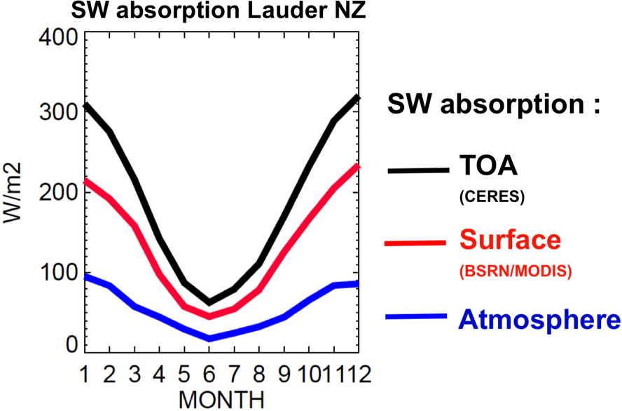

Figure 1: Annual cycle of total (TOA), surface and atmospheric column absorption determined at the BSRN site Lauder in New Zealand based on 5 years data from BSRN, MODIS and CERES-EBAF.
- Recommendations

a) Recommendations with respect to the TOA radiation budget components:
- The international community should urge government agencies responsible for building the next generation of Earth Radiation Budget instruments to include onboard calibration equipment that can detect and correct for on-orbit contamination of optics. Lessons learned from over a decade of in-flight experience (e.g., with CERES FM1-FM4 and the SORCE TIM, Kopp et al. 2005) clearly provide evidence that on-orbit contamination of optics does occur and must be detected and corrected for in order to ensure a robust climate record of TOA radiation budget.
- The international community should urge government agencies responsible for building the next generation of Earth Radiation Budget instruments to provide sufficient time for ground calibration activities. Ground calibration is the last major test performed prior to shipment, when there are typically no financial or schedule reserves left. Shortening the length of the ground calibration period due to cost/schedule constraints adds uncertainty to the absolute calibration of the instrument.
- The international community should urge government agencies responsible for building the next generation of Earth Radiation Budget instruments to periodically re-verify the traceability of calibration targets on the ground.
- The international community should urge government agencies responsible for building the next generation of Earth Radiation Budget instruments to establish collaborations with other international agencies specializing in calibration standards (e.g., NIST, NRL).
- The international community should provide guidance on the creation of Earth Radiation Budget climate data records. There is a naive notion in the community that complex climate data records involving a significant level of fusion of multiple data sources at climate accuracy can be transitioned from research to operations. The decades of expertise used to validate, understand, quality control, and continuously fix problems with instrument or ancillary input data sets cannot be bought or transplanted as a set of documents and software. Earth Radiation Budget Climate Data Records capable of accurately characterizing climate at decadal time-scales are inherently more research data products than they are operational data products. Assuming otherwise will likely lead to inferior data products characterized by artifacts that go unnoticed and unresolved in an operational processing environment. While an operational approach works fine for processing weather data, far more rigor and quality assurance is necessary for climate data products, where reprocessing is an integral part of the effort.

b) Recommendations with respect to the surface/atmospheric radiation budget components:
- A continued and expanded operation and maintenance of a well calibrated network of long term surface radiation stations is required to provide direct observations and anchor sites for satellite-derived products and climate model validation, as well as for the detection of important changes in the radiation fields either not detectable by satellites or anticipated by models. The basic measurements include the four primary components (up and down, longwave and shortwave irradiance) with high temporal resolution (minute values) and known accuracy (BSRN accuracy standards).
- These high accuracy observation sites should be expanded to under-represented regions of the globe (such as many low latitude areas) and particularly oceans where alternate or modified observational strategies might be necessary. The use of newly available shortwave radiometers (SPN-1) that are well suited for use in remote deployments such as on buoys and ships, is recommended. These new radiometers comply with low-power systems measuring both diffuse and direct fluxes, which allows for proper correction of tilt from horizontal (Long et. al, 2010)
- Anchor sites should also include direct and/or diffuse shortwave measurements in addition to total incoming shortwave (SW) along with standard surface meteorological measurements. These measurements are useful for the diagnosis of cloud effects on the radiation budget (Zhang et al. 2010), for the evaluation of satellite-derived products and climate models, and for climate impact research (for example biosphere growth and terrestrial carbon uptake, Mercado et al. 2009).
- To improve surface albedo estimates over various surface types and for the assessment of satellite derived albedo products, high accuracy spectral and broadband measurements from towers are desirable at the anchor sites (Roman et al. 2009).
- Atmospheric spectral optical depths should be observed to infer atmospheric column abundance of aerosol, ozone, water vapor and other atmospheric constituents.
- The spatial representativeness of surface anchor sites has to be thoroughly assessed (Dutton et al. 2006, Roman et al. 2009). The possible “urbanization” effect (impact of local air pollution) in surface solar radiation trends needs quantification.
- To achieve progress in the accuracy of satellite-derived surface radiation fields, improved and consistent satellite estimates of vertical distributions of cloud and aerosol radiative properties (size, single scattering albedo, asymmetry parameter) and of water vapor are required

- Plans

The integration of surface and TOA measurements to obtain a 3-dimensional picture of the spatio-temporal variation of the global energy balance is at its early stage and needs to be implemented in the coming years. By combining collocated surface and TOA estimates the atmospheric radiation balance can be inferred. Information from surface observations, satellite-derived products and reanalyses need to be merged to provide best estimates of the 4 dimensional spatio-temporal variation of the radiative flux fields. An extended 10 years dataset of CERES-EBAF radiative fluxes will become available soon from NASA-Langley, which will allow an extension of the evolution of the global energy balance to 2010. The above products will be timely to provide better constraints for climate model development and for the evaluation of radiative flux fields in global and regional climate models in the context of the 5th IPCC assessment report (AR5) .
Additional WG members will be appointed as required to achieve the WG goals. For example the inclusion of fluxes calculated in reanalyses could be considered as an additional data source. An optimal candidate for a WG member with related expertise could be Jean-Jacques Morcrette from ECMWF. To foster applications of the Global Energy Balance data in the medium term, data users should also be included in the WG, such as Richard Allan from University of Reading (expertise on connecting the energy and water cycles.

V. Cited References

Dutton, E. G., and co-authors (2006), Decadal variations in surface solar irradiance as observed in a globally remote network, J. Geophys. Res., 111, doi: 10.1029/2005JD006901.
Hatzianastassiou, N., et al. (2005), Global distribution of Earth’s surface shortwave radiation budget, Atmos. Chem. Phys., 5, 2847– 2867.
Kopp, G., Lawrence, G., and Rottman, G. (2005), The Total Irradiance Monitor (TIM): Science Results, Solar Physics, 230, 29-140
Loeb, N. and coauthors (2009), Toward optimal closure of the Earth’s top-of- atmosphere radiation budget, J. Climate, 22, 748-766.
Long, C. N., A. Bucholtz, H. Jonsson, B. Schmid, A. Vogelmann, and J. Wood (2010), A Method of Correcting for Tilt from Horizontal in Downwelling SW Measurements on Moving Platforms, TOASJ, 4, 78-87, doi: 10.2174/1874282301004010078.
Long, C. N. and T. P. Ackerman (2000), Identification of Clear-skies from Broadband Pyranometer Measurements and Calculation of Downwelling Shortwave Cloud Effects, J. Geophys. Res., 105, No. D12, 15609-15626.
Mercado, L.M., N. Bellouin, S. Sitch, O. Boucher, C. Huntingford, M. Wild, and P.M. Cox (2009), Impact of Changes in Diffuse Radiation on the Global Land Carbon Sink, Nature, 458, 1014-1018.
Roman, M.O., and co-authors (2009), The MODIS (Collection V005) BRDF/albedo product: Assessment of spatial representativeness over forested landscapes, Remote Sensing Environm., 113, 2476–2498.
Wild, M. (2008), Shortwave and longwave surface radiation budgets in GCMs: a review based on the IPCC-AR4/CMIP3 models. Tellus, 60, 932 - 945. doi: 10.1111/j.1600-0870.2008.00342.x.
Zhang, Y., C. N. Long, W. B. Rossow, and E.G.Dutton (2010): Exploiting Diurnal Variations to Evaluate the ISCCP-FD Flux Calculations and Radiative-Flux-Analysis-Processed Surface Observations from BSRN, ARM and SURFRAD, JGR, doi:10.1029/2009JD012743, in press.

