The Third APRS (Asia Pacific Radiation Symposium) in Seoul, Korea
25-28 August 2010

The third APRS (Asia Pacific Radiation Symposium) was held at the International Conference Hall, Yonsei University, Seoul, Korea, from August 25th to 28th, 2010. The Symposium was organized by Yonsei University and Seoul National University, with support from the BK21 Program, CATER (Center for Atmospheric and Earthquake Research), and KMS (Korea Meteorological Society). The first APRS was held in Xian, China in 2003, and the second in Kanazawa, Japan. In the third APRS in Seoul, Korea, a total of 117 (59 oral and 58 poster) presentations were made with over 150 participants from regions of Asia and the Pacific Rim, including China, Japan, Korea, New Zealand, and the U.S.A. Participants from European countries including Germany and Netherland attended as well. Profs. B.J. Sohn (Seoul National University) and Jhoon Kim (Yonsei University, Seoul) led the organizing committee for this third APRS. The third APRS has shown the potential to expand the community in the region, and will serve as the basis for the success of future meetings. The launch of COMS (Communication Oceanography and Meteorological Satellite) in July, 2010 and ambitious future programs in Korea also attracted many scientists to the field.

The aims of this symposium were to promote scientific research related to atmospheric radiation in the Asia-Pacific region, collaboration among scientists, and encouragement of young scientists in this region. Furthermore, this symposium, held every 4 years in between the IRS (International Radiation Symposium) is recognized as a daughter program of the IRS by the IRC (International Radiation Commission). Dr. Robert F. Cahalan (NASA Goddard Space Flight Center) participated as the President of IRC, giving welcome remarks in the Opening Session and an invited talk at the Plenary Session. The symposium was initiated with the opening comments by Prof. B.J. Sohn, and all the participants were welcomed by Prof Tae Young Lee, the Dean of Yonsei Graduate School. There were continuing invited talks by world-leading scientists in the Plenary Session, Prof. Kuo Nan Lioou (UCLA), Prof. Zhanqing Li (Univ. of Maryland), Prof. Teruyuki Nakajima (Univ. of Tokyo), Prof. Soon Chang Yoon (Seoul National Univ.) in the theme of radiative transfer and climate change. The Symposium was held as a single session throughout the whole period, and hosted eminent invited speakers in their respective areas, Prof. Daniel Jacob (Harvard Univ.), Dr. P.K. Bhartia (NASA GSFC), Prof. Ping Yang (Texas A&M Univ.), Prof. Andy Dessler (Texas A&M Univ.), and Prof. B.J. Sohn (SNU). Active and constructive discussions were continued throughout the Symposium on the recent research activities among the participants. It is noteworthy to have seen many young scientists during the Symposium, which reflects the future of the community. The six session held as a series included (1) Interactions of radiation with clouds, aerosols and their climate impact, (2) Ground based, aircraft and satellite remote sensing of clouds, aerosol, trace gases and surface properties, (3) Observational and theoretical studies of earth radiation budget, (4) Advanced radiation parameterizations in numerical models, (5) Observational and theoretical studies including nonspherical particle scattering and 3-D radiative transfer, and (6) Other. APRS is expected to have continuing success in the future with a solid basis established in all three meetings to date, which will eventually promote studies on radiative transfer and satellite remote sensing in the Asia-Pacific region.

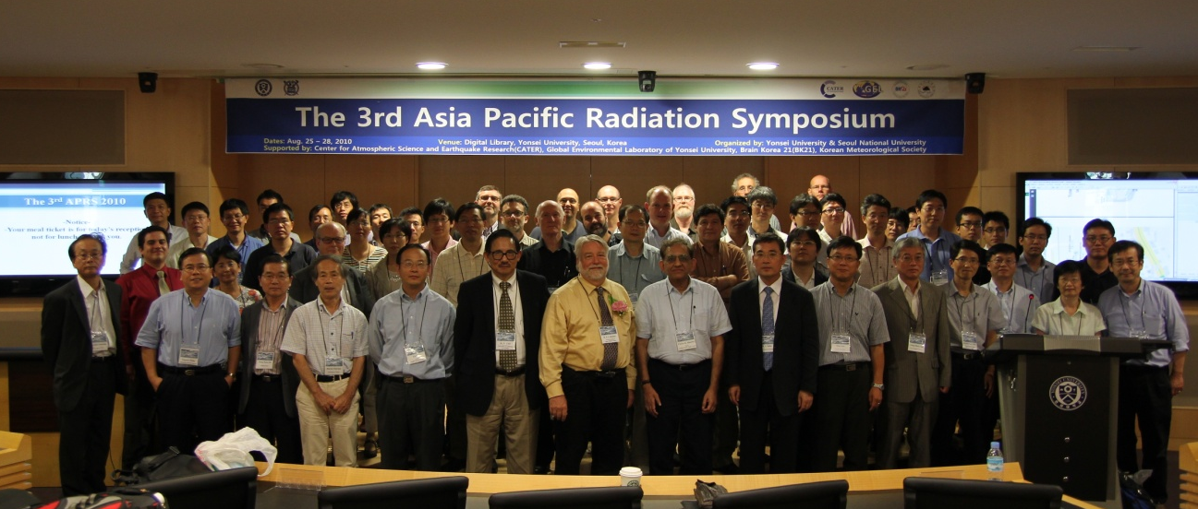
Participants at the 3rd APRS held 25-28 August 2010 in Seoul, Korea.

